**BUS RESERVATION SYSTEM USING PYTHON**

**21ES602 – EMBEDDED SYSTEM PROGRAMMING**

**Date: 21-01-2023**

**Roll No: cb.en.p2ebs22006**

1. main.py

# Data importing section  
from passengerinfo import *  
from TicketShow import *  
from admin import *  
  
global ch # declared global variable  
  
print("---------------------------------------------------")  
print(" Welcome To DSG Bus Travel ")  
print("---------------------------------------------------")  
print()  
  
  
def start(): # called function  
 print("1. Admin Registration :")  
 print("2. Admin Login :")  
 print()  
 adminObj = Admin()  
 ch = int(input("Choose Correct option :"))  
  
 if ch == 1:  
 # admin class object creation  
 adminObj.adminRegistration()  
  
 if ch == 2:  
  
 adminObj.adminLogin()  
  
 print()  
 print("1. Passenger Registration :")  
 print("2. Show Ticket :")  
 print()  
 ch = int(input("Choose Any One Option :"))  
 if ch == 1:  
 pd_obj = PassengerDataCsv()  
 pd_obj.getPassengerInfo()  
 pd_obj.saveInfo()  
 elif ch == 2:  
 obj = TicketShow()  
 obj.ticketShow()  
  
  
start() # calling function  
# =======================================================================

1. passengerinfo.py

import csv  
  
  
class PassengerRegistration():  
 # constructor  
 def __init__(self):  
 self.passengerName = None  
 self.noOfPassenger = None  
 self.departureLocation = None  
 self.destinationLocation = None  
 self.ddmmyyyy = None  
 self.seatNo = None  
 self.selectBusType = None  
 self.busFare = None  
 self.autoInc = 1  
 self.countcol = 0  
  
 def getPassengerInfo(self):  
 self.passengerName = input("Enter Passenger Name :")  
 self.noOfPassenger = int(input("Enter Number Of Passenger :"))  
 print("1: Coimbatore")  
 print("2: Chennai")  
 print("3: Madurai")  
 print("4: Trichy")  
  
 # Enter departure Location Name START  
 self.dl = int(input("Enter Departure Location"))  
 if self.dl == 1:  
 self.departureLocation = "Coimbatore"  
 elif self.dl == 2:  
 self.departureLocation = "Chennai"  
 elif self.dl == 3:  
 self.departureLocation = "Madurai"  
 elif self.dl == 4:  
 self.departureLocation = "Trichy"  
 else:  
 print("Please Enter correct choice :")  
 # departure Location Name END  
  
 print("1: Kochin")  
 print("2: Bangalore")  
 print("3: Hyderabad")  
 print("4: Tirupati")  
 # Enter destination Location Name START  
 self.dpl = int(input("Enter Destination Location :"))  
 if self.dpl == 1:  
 self.destinationLocation = "Kochin"  
 elif self.dpl == 2:  
 self.destinationLocation = "Bangalore"  
 elif self.dpl == 3:  
 self.destinationLocation = "Hyderabad"  
 elif self.dpl == 4:  
 self.destinationLocation = "Tirupati"  
 # Enter destination Location Name END  
  
 self.ddmmyyyy = input("Enter Date of Journey Like DD-MM-YYYY :") # Date of Journey  
  
 # Booking Seat Start  
 print("[1]__[2]__[3]__[4]__[5]__[6]__[7]__[8]__[9]__[10]")  
 print("[11]_[12]_[13]_[14]_[15]_[16]_[17]_[18]_[19]_[20]")  
 print("[21]_[22]_[23]_[24]_[25]_[26]_[27]_[28]_[29]_[30]")  
  
 seatNoList = [1, 2, 3, 4, 5, 6, 7, 8, 9, 10, 11, 12, 13, 14, 15, 16, 17, 18, 19, 20, 21, 22, 23, 24, 25, 26, 27,  
 28, 29, 30]  
 self.bookingList = []  
 while True:  
 self.seatNo = int(input("Choose a Seat Number & Max To Max You Can Book Two Ticket :"))  
 if self.seatNo <= 30:  
  
 if self.seatNo in seatNoList:  
 self.bookingList.append(self.seatNo)  
 del seatNoList[self.seatNo + 1]  
 count = len(seatNoList)  
 else:  
 print("Ticket Allready Booked")  
 print("Do You Want To Book One More Seat Enter (Yes/No)")  
 y = input("")  
 if y == "Yes":  
 pass  
 else:  
 break  
  
 else:  
 print("Don't Choose a Seat Number Which is Not Available")  
 # Booking Seat END  
  
 print(" 1. AC BUS = 500 Fare")  
 print(" 2. NON AC BUS = 300 Fare")  
 self.busType = int(input("Select Bus Type :"))  
  
 if self.busType == 1:  
 self.selectBusType = "AC BUS"  
 self.busFare = self.noOfPassenger * 500  
 elif self.busType == 2:  
 self.selectBusType = "NON AC BUS"  
 self.busFare = self.noOfPassenger * 300  
  
 # Booking Seat END  
  
  
# =============================================  
# saving Passenger Data into csv File  
# =============================================  
class PassengerDataCsv(PassengerRegistration):  
 def saveInfo(self):  
 try:  
 with open("passengerData.csv", 'r+', newline="") as f:  
 r = csv.reader(f)  
 data = list(r)  
 # print(self.data)  
 for i in data:  
 self.autoInc += 1  
 for j in i:  
 self.countcol += 1  
 print()  
 print("The Ticket Booking ID is :", self.autoInc)  
 print("Number of Records Are Found In Database :", self.autoInc)  
  
 except:  
 print("File has not available")  
 finally:  
 with open("passengerData.csv", 'a+', newline="") as f:  
 w = csv.writer(f)  
 # w.writerow(["Auto Increment","passenger Name","Number of Passenger","Departure Location","Destination Location","ddmmyyyy","Seat No","Select Bus Type","Bus Fare"])  
 w.writerow([self.autoInc, self.passengerName, self.noOfPassenger, self.departureLocation,  
 self.destinationLocation, self.ddmmyyyy, self.bookingList, self.selectBusType,  
 self.busFare])  
 print("Data Save successfully")  
 print()  
  
  
'''pd_obj = PassengerDataCsv()  
pd_obj.getPassengerInfo()  
pd_obj.saveInfo()'''

1. TicketShow.py

# Data Importing section  
from passengerinfo import *  
  
  
class TicketShow:  
  
 def ticketShow(self):  
 bln = [] # list for storing data and retrieving from passengerData.csv file  
 with open("passengerData.csv", 'r+', newline="") as f:  
 r = csv.reader(f)  
 data = list(r)  
 id = int(input("Enter Your Booking Id :"))  
 for i in data:  
 if id == int(i[0]):  
 for j in i:  
 bln.append(j)  
 break  
 # print(bln)  
 print("------------------------------------------------------------------------------")  
 print(" DSG Bus Travel ")  
 print("------------------------------------------------------------------------------")  
 print()  
 print(" e_Ticket :", "Coimbatore Address : C-2, Peelamedu, Coimbatore")  
 print(" ", "Phone No\Mob No : 8000800088,8888880000 ")  
 print()  
 print("", bln[3], "------------->", bln[4], " ", " Passenger Id:", bln[0])  
 print()  
 print(" Passenger Name :", bln[1], " ", "Number of Passenger :", bln[2])  
 print("______________________________________________________________________________")  
 print()  
 print(" Date of Booking :", bln[5], " ", "Seat No :", bln[6], " ")  
 print()  
 print(" Bus Type : ", bln[7], " ")  
 print(" Bus Fare : ", bln[8], " ")  
 print()  
 print("------------------------------------------------------------------------------")

1. admin.py

import csv  
  
  
class Admin:  
 def __init__(self):  
 self.username = None  
 self.password = None  
  
 def adminRegistration(self):  
 print("----------------------------------------------------------------")  
 print()  
 with open("adminCredential.csv", 'w', newline="") as f:  
 w = csv.writer(f)  
 self.username = input("Enter and set username :")  
 self.password = input("Enter and set your password :")  
 # saving a data into database  
 w.writerow([self.username, self.password])  
 print("Registration successfully")  
 print()  
 print("----------------------------------------------------------------")  
  
 def adminLogin(self):  
 actList = [] # list for storing data and retrieving from adminCredential.csv file  
  
 with open("adminCredential.csv", 'r+', newline="") as f:  
 r = csv.reader(f)  
 data = list(r)  
 for i in data:  
 for j in i:  
 actList.append(j)  
  
 # print(actList)  
 while (True):  
 print("----------------------------------------------------------------")  
 print()  
 self.username = input("Enter username :")  
 self.password = input("Enter password :")  
 if self.username == str(actList[0]) and self.password == str(actList[1]):  
 print()  
 print("Login successfully")  
 break  
 else:  
 print("Enter correct username and password")  
 print()  
 print("---------------------------------------------------------------")

**OUTPUT:**

User Registration

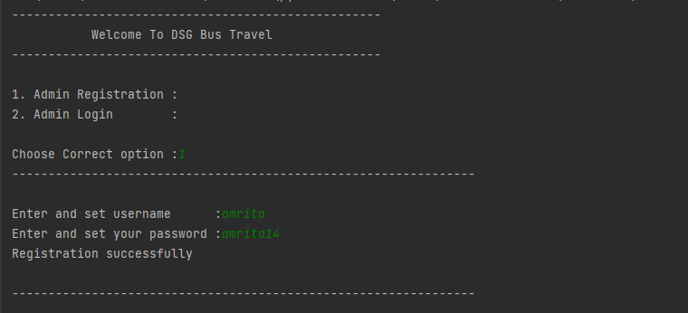

User Login

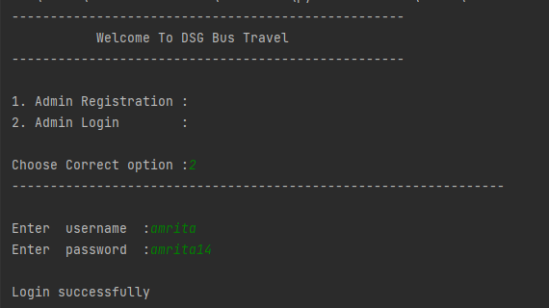

Passenger Registration and User Inputs

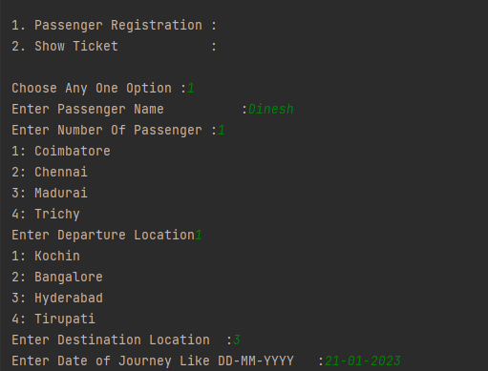

Seat Booking

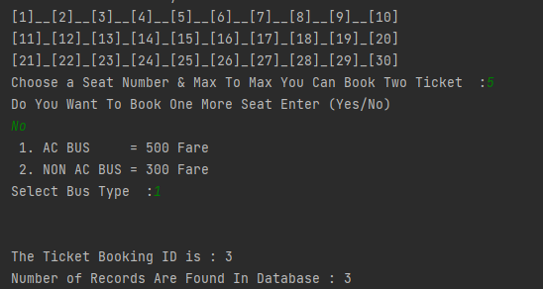

Ticket Generation

